**Payments to Foreign Vendor/Supplier**

**NOTE:** In BUY.IU the location of where services were performed must be indicated on Requisitions for foreign suppliers. Click [**HERE**](https://controller.iu.edu/cgi-bin/cfl/dl/202007231046078488031485) for assistance

**Determining Tax on Payment to Foreign Vendors/Suppliers**

Our department is responsible for withholding taxes from certain payments made to foreign vendors. To assist in this process you must first consider where the actions were performed or used when making a payment to a foreign vendor for any of the following:

* Services performed
* Access to the internet
* "Right to use" a product

Tax needs to determine whether these payments are taxable or non-taxable by following the criteria listed in the table below. Either outcome requires the submitting department to provide documentation prior to the approval of these payments.

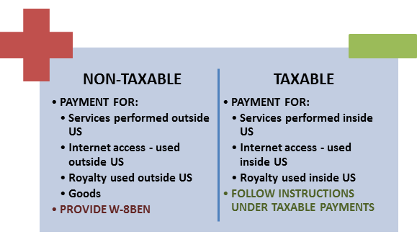

**Non-Taxable Payments**

Any of these type of payments performed or used **outside of the US** will not be subject to US taxes. Also, tangible goods purchased from a foreign vendor are not subject to U.S. income tax. The Tax department will only need a current [W-8](https://purchasing.iu.edu/buying/suppliers.php) to approve any payment fitting this description.

**Taxable Payments**

Alternatively, when any of the above actions are performed or used within the US. The payment will be subject to income tax and IU is required to withhold at 30%, unless the individual qualifies for [tax treaty](https://controller.iu.edu/compliance/form-library). Select the appropriate type of payment and use the instructions provided to process these types of payments.

**Services or Honorarium**

Caution: US law significantly restricts what employment foreign nationals may accept. Consult with the Office of International Services before committing to an honorarium.

* [Visas for Faculty, Staff & Visitors](https://ois.iu.edu/visas/faculty-visas/index.html)

The process for paying an international vendor for services performed within the US is explained in the [Quick Guide](https://training.iu.edu/index.shtml). Please indicate on the tax cover sheet whether the department will pay for the tax if the vendor does not qualify for tax treaty benefits. If the department requests to “gross up” the payment, tax will make the adjustment when the payment is routed to us for approval.

### Example of Gross Up Calculation

$1,000 payment to foreign vendor for services rendered.

|  |  |
| --- | --- |
| Gross Up Amount (Charged to Dept.) | 1,000 ÷ (1 - 30%) = 1,428.57 |
| Tax Calculation | 1,428.57 × 30% = 428.57 |
| Net Check Amount | 1,428.57 - 428.57 = 1,000 |

**On-Line Use of Foreign Libraries**

When IU pays a fee to allow students or staff located in the US to access books or data in a foreign library the fee is considered a taxable royalty. The university is required to withhold tax at 30% unless the vendor claims tax treaty on their completed [Form W-8](https://purchasing.iu.edu/buying/suppliers.php).

**Royalty**

Royalties from publishing a book, licensing a patent or other form of intellectual property are taxable to the recipient.  If the vendor is a foreign company or individual, the university must deduct 30% federal income tax unless tax treaty benefits are claimed on their [W-8](https://purchasing.iu.edu/buying/suppliers.php) form. Residents of certain countries may be entitled to reduced tax rates or exemption from tax under a tax treaty between their country and the U.S. Review the page below for more information on treaty benefits.

**Software & Internet Access**

### Payment is for the Right to Own

* Ownership is a purchase where rights and responsibility are transferred to IU indefinitely, without restrictions (e.g. “off-the-shelf” boxed software.)
* Purchase is not taxed

### Payment is for the Right to Use or to Allow Access for a Limited Period of Time

### The right to use means the vendor retains ownership.  IU is making a payment only for the right to use intellectual property.

### If IU can access either the program or the data indefinitely then it will not be taxable.

### If IU has access for a limited time then the payment will be taxable as a royalty at 30% unless the vendor claims a tax treaty on their completed [Form W-8.](https://purchasing.iu.edu/buying/suppliers.php)