**Collecting Indiana Sales or Use Tax on Sales**

Sales of tangible personal property as part of a proprietary activity by Indiana University are subject to sales tax. A few examples specific to IU are Catering, Hotel and Conference Center, Golf Course and any activity customarily associated with being competitive with private enterprise.

The term **"tangible personal property"** means personal property that: 1) can be seen, weighed, measured, felt, or touched: or 2) is in any other manner perceptible to the senses.  The term includes electricity, water, gas, stream, and prewritten computer software.

Proprietary activities, as defined by the state of Indiana, are illustrated as:

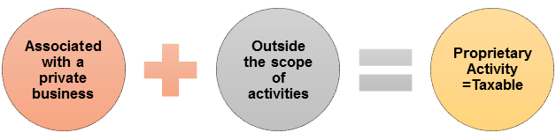

**Consult the**[**Collection Matrix**](https://controller.iu.edu/cgi-bin/cfl/dl/2020100815411184306727337)**for specific guidance on what sales are exempt or taxable.**

**Exempt Sales**

Indiana University is excused from charging tax on sales involving the educational mission for which the institution is granted exemption. The mission falls into these primary categories:

* Teaching and instruction
* Research
* Public service

Some transactions exempt from the sales and use tax are:

* Sales for resale
* Sales or rentals outside the State of Indiana
* Sales or rentals to the federal government or their agencies
* Sales or rentals to a non-profit organization providing an Indiana Form ST-105 (**note:** Department must collect ST-105 and keep form on file for 3 calendar years.)
* Sales of food by IU to an IU enrolled student